
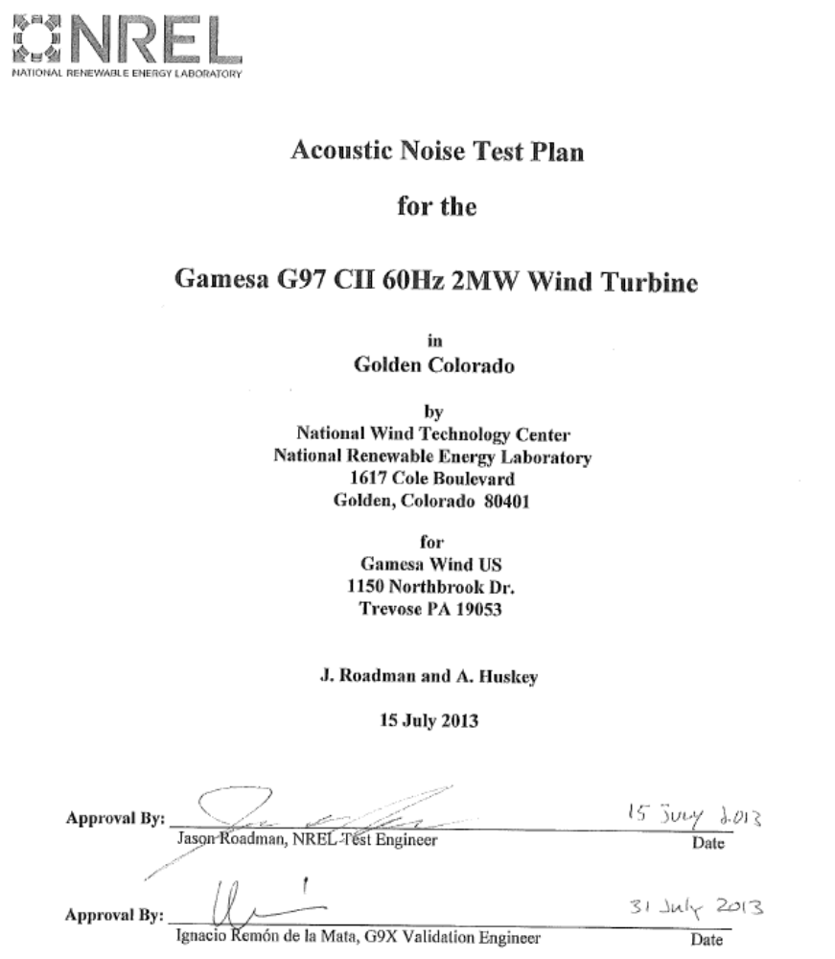

Acoustic Noise Test Plan

for the

Gamesa G97 CII 60Hz 2MW Wind Turbine

in
Golden Colorado

by
National Wind Technology Center
National Renewable Energy Laboratory
1617 Cole Boulevard
Golden, Colorado 80401
for
Gamesa Wind US
1150 Northbrook Dr.
Trevose PA 19053

J. Roadman and A. Huskey

15 July 2013

Approval By:
Jason Roadman, NREL Test Engineer Date
Approval By:
Ignacio Remón de la Mata, G9X Validation Engineer Date

Test Objective
The primary goal of the test is to characterize the acoustic emissions of the Gamesa G97 wind turbine in accordance with the International Electrotechnical Commission’s (IEC) standard, Wind turbines part 11: Acoustic Noise Measurement Techniques, IEC 61400-11, Edition 2.1, 2006-11 and the Measuring Network of Wind Energy Institutes (MEASNET) standard, Acoustic Noise Measurement Procedure, Edition 2. Hereafter these documents are referred to as the Standards. This test plan documents the measurement techniques, test equipment, and analysis procedures for the following quantities at integer wind speeds from 6 to 10 m/s:

- apparent sound power level,
- one-third octave band levels, and
- tonality.

In addition, the National Wind Technology Center (NREL) plans to conduct this test in accordance with its quality system procedures such that the final test report will meet the full requirements of accreditation by A2LA. NREL’s quality system procedures require that the test meet all applicable requirements specified by A2LA, Measnet, and ISO/IEC 17025 (or to note any exceptions in the test report).

After approval, this test plan represents a commitment by both NREL and DOE to conduct the test according to the methods described herein.

Test Turbine
The test turbine will be a G97 CII wind turbine. It is a horizontal axis, three bladed, upwind turbine with full span pitch control. Table 1 provides the key descriptive information of the test turbine.
Table 1. Test Turbine Configuration
Turbine manufacturer and address | Gamesa Wind US, 2050 Cabot Boulevard West  Langhorne PA 19047-1811
Make, Model, Serial Number | Gamesa, G97 2MW, sn. 100184308
Production Year of Turbine | 2012
Rotor Diameter (m) | 97m
Hub Height (m) | 90m
Horizontal distance from rotor center to tower axis (m) | 4.44m
Stall or pitch-controlled | Pitch-controlled
Tower Type | Trunk – conical tubular
Rated Electrical Power (kW) | 2000
Rated Wind Speed (m/s) | 10.5 m/s
Rotor speed range (rpm) | 9.8 rpm – 17.8 rpm
Rotor control devices | Vortex Generators
Number of Blades | 3
Blade Tip Pitch Angle (deg) | Variable
Blade make, type, serial number | LM GlassFiber, 44000004, 4400001, 4400005
Generator make, type, serial number | Indar TAR500L4R sn. 20616000000
Gearbox make, type, serial number | HANSEN EH806AN21-BN sn EH806A-033/LM0001
Control software | COSMOS

Test Site
The test turbine is located at site 4.5 at the National Wind Technology Center, 8 miles south of Boulder, Colorado, USA. Figure 1 shows the turbine and permanent meteorological tower locations. This figure also shows nearby obstructions and topographical features of the site. Figure 2 shows a wind rose listing the distribution of the winds at the site gathered during the site assessment. Predominant wind is generally accepted to be 292° true.

Figure 3 details potential sound board locations. The blue shaded regions show locations that provide appropriate ±15° measurement sectors and also meet the inclination angle constraints. A 10m met mast is located 323m on a bearing of 115° true from the turbine, approximately upwind for prevailing winds. This configuration will ensure that data can be collected according to the standard without requiring an exception. Any deviation from these locations would only be utilized if mutually agreed upon by NREL and Gamesa. For practical purposes, the same met mast and sound board locations will be used as in previous tests for this site.
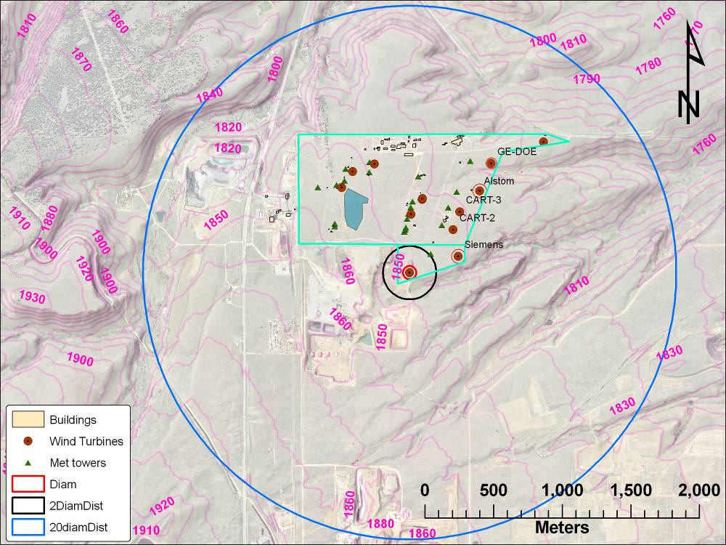
Figure 1. Test Turbine Location
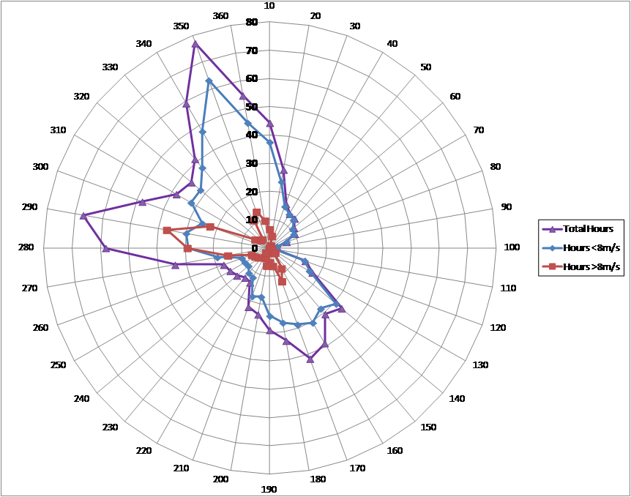
Figure 2. Wind distribution from site calibration.

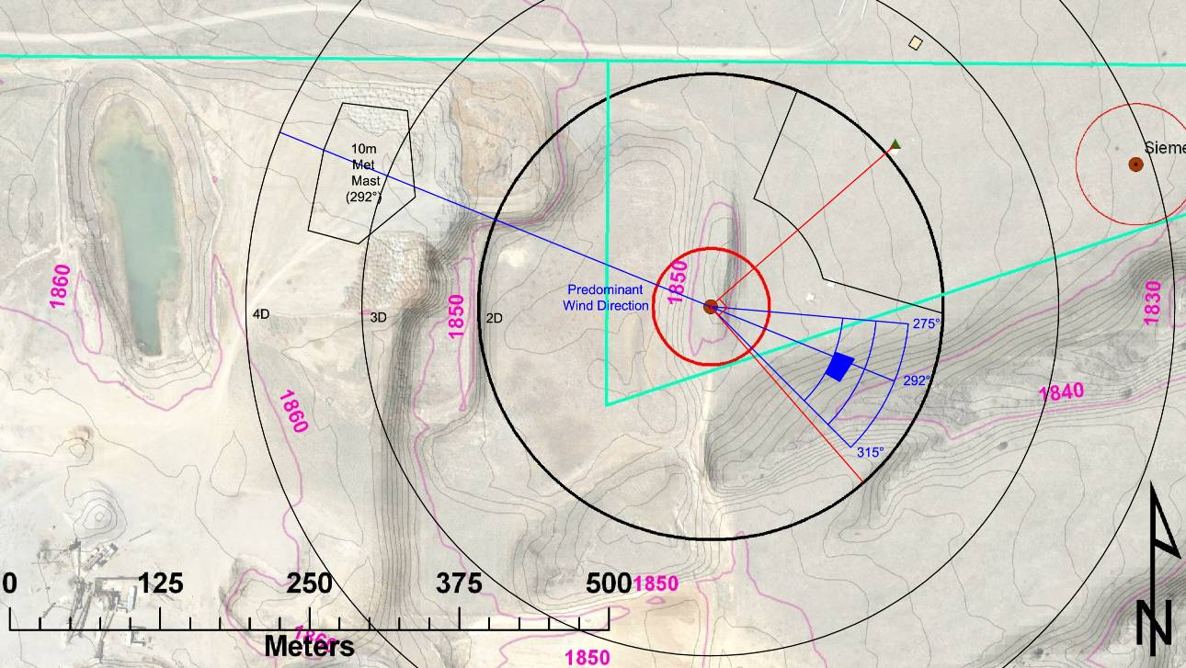
Figure 3. Possible sound board and temporary anemometer
locations (1m contour intervals)

Nearby sources of noise that might interfere with noise testing of the test turbine are given in Table 2.
Table 2. Nearby noise sources
Source | Location | Shutdown for noise test
GE 1.5 | 4.0 | As needed
Alstom ECO110 3.0MW | 4.1 | As needed
CART-3 | 4.3 | Yes
CART-2 | 4.3 | Yes
Siemens 2.3MW | 4.4 | Yes
Southwest Windpower Skystream (2 turbines) | 3.2 | No

Test Instrumentation
Table 3 shows the list of instrumentation that will be used for the test. For acoustic measurements when the turbine is operating below 95% rated power, the power will be measured and wind speed will be derived from the power curve. For points above 95% rated power, the wind speed will be derived from the correlation between nacelle anemometer and the wind speed derived from power per the standard. For background noise measurements, the wind speed will be measured using the 10 m anemometer and correlated to the wind speed derived from turbine power. A microphone with wind screen will be placed in the downwind reference position to measure the total and background noise.
Table 3. Equipment list
Instrument | Manufacturer | Model Number
Signal Analyzer | Delta Acoustics | Noiselab Professional 3.0
Microphone | Bruel & Kjaer | 4189-A-021
Preamplifier | Bruel & Kjaer | 4012
Calibrator | Bruel & Kjaer | 4230
Digital Recorder | Delta Acoustics | Noiselab Professional 3.0
Anemometer (10m tower) | Thies | First Class
Nacelle anemometer | Gamesa controller | NA
Wind Vane | Met One | SD-201
Pressure Sensor | Vaisala | PTB101B
Temperature Sensor | Met One | T200
Power | Camille Bauer | Sineax M 563
Meteorological Data Acquisition System | National Instruments | EtherCAT
Pitch angle | Gamesa controller | NA
Rotor speed | Gamesa controller | NA
Power | Gamesa controller | NA

Test Procedures
Testing will begin once three conditions are fulfilled:
- This test plan is complete and signed by both the client and NREL
- NREL has complete installation and checkout of meteorological and turbine instrumentation required for the test
- The client has signed a test readiness document that indicates that the turbine is ready for testing.

The test will continue until, at a minimum, all requirements listed in Table 4 are fulfilled. Testing will continue until Gamesa and NREL agree that sufficient data has been collected.
Table 4. Minimum Data Requirements for Acoustics test
Measurement Type | Requirements
Overall measurements | At least 30 one-minute averages.
For A-weighted sound pressure level: (for turbine and background measurements) | At least 3 minutes of data with wind speeds ±0.5 m/s of the integer values of 6, 7, 8, 9, and 10 m/s
For octave or third octave band measurements: (for turbine and background measurements) | At least 3 minutes of data with wind speeds ±0.5 m/s of the integer values of 6, 7, 8, 9, and 10 m/s
Narrow band measurements:  (for turbine and background measurements) | At least 2 minutes of data with wind speeds ±0.5 m/s of the integer values of 6, 7, 8, 9, and 10 m/s

Reporting
Within 12 hours of the conclusion of a measurement session, an email will be sent that includes a table detailing the collected turbine and background measurements binned against measured wind speed.

More detailed preliminary reports will be issued within 48 hours after a measurement session concludes, ideally sooner if personnel availability allows. These reports will include:
- A table detailing total acquired data sets to date and sound pressure levels per wind speed bin (1-min averages)
- A graph of sound pressure level versus hub height wind speed (1-min averages)
- A graph of sound pressure level versus output power (1-min averages)
- A graph of sound pressure level versus pitch angle (1-min averages)

The final report will include:
- Description of the test turbine
- Description of the test site
- Description of the test instrumentation
- Description of the measurement procedure
- Results with uncertainty including:
  - A-weighted sound power level (as function of standardized wind speed, rotor speed and power)
  - Plots of all data and regression lines
  - One-Third Octave Spectra (graphical and tabular)
  - Tonal analysis
  - Low frequency analysis
- Exceptions to the requirements of the IEC and MEASNET standards, test plan, or NREL quality system
- Raw and processed data will be made available to Gamesa, preferably in MS Excel format. Note, as some of what is listed below was not part of the original scope of work, this data will be made available as close to the original agreed upon timing, but may not immediately accompany the report.
  - 1-second and 1-minute averaged data
  - Description of variable names
  - Tables showing total number of wind speed bins
  - Sound power level vs. wind speed at 10 m per wind speed bin
- A final test result summary will be included separately that follows the Gamesa supplied format listed on below.

Wind speed at 10m height [m/s] | 3 | 4 | 5 | 6 | 7 | 8 | 9 | 10
Electrical power output calculated from the power curve [kW]
Measured pitch angle [degrees]
Measured rotor speed [1/min]
Sound power level [dB]
Combined uncertainty in the sound power level, U_{C} [dB]
Tonality, ΔL_{k} [dB]
Tonal audibility, ΔL_{a,k} [dB]
Frequency of the most prevalent tone [Hz]

Roles and Responsibilities
Table 5 lists the planned test team, and identifies roles and responsibilities for each team member.

Table 5. Roles of Test Participants
Title | Name | Role(s)
Test Engineer | Jason Roadman  NREL | Overall test management and responsibility.  NREL approval of test plan.  Test set-up, checkout, conduct.  Collection of test data.  Analysis of test data.  Resolution of problems during testing.  Review and report test results.  Final report
Test Engineer | Arlinda Huskey  NREL | Collection of test data.  Resolution of problems during testing.  Review of test data, results, and report.
Test Technician | Jerry Hur  NREL | Selection of instruments  Installation, maintenance and checkout of test equipment  Implementation of corrective actions for problems  Responsible for ensuring safety of personnel and equipment at test site.
Turbine Technician | Aaron Rodgers | Operation and maintenance of test turbine (under  supervision of site manager)
Client, Test Engineers | Paula Negro Muniain, Gamesa | Supervise operation and maintenance of test turbine.  Primary turbine manufacturer contact for NREL  Provided information needed for test plan  Reports any change in turbine configuration to NREL  Resolution of any problems with test turbine  Provides test evaluation to NREL
Client | Ignacio Remón de la Mata, Gamesa | Approve test plan

Schedule
All test equipment is on site. NREL is ready to start measurements and will begin data collection as soon as appropriate winds are available, the turbine is in good working order, and the data acquisition system has been checked out after the turbine is repaired. Specific measurement dates will be agreed upon between NREL and Gamesa based on the meteorological forecast for WTG site. Typically these decisions will require response with less than 48 hours of notice. Data collection will continue until Gamesa and NREL agree that sufficient data has been collected.

